Incident Report – RDP Brute Force With Successful Authentication

1. Report Title
RDP Brute Force Activity With Successful Authentication – Workstation 192.168.10.10

2. Date of Report
01-15-2026

3. Reported By
SOC Analyst

4. Severity Level
Medium

5. Summary of Findings

On 2026-01-15, an external IP address 14.136.73.18 performed 41 brute-force attack against a Windows endpoint “MTS-ContractorPC2” (192.168.10.10) using the Remote Desktop Protocol (RDP).

Between 19:41:10 and 19:46:35 UTC, the attacker established an inbound RDP connection and successfully authenticated to the host. Review of available telemetry shows no evidence of post-authentication activity, such as command execution, process creation, lateral movement, or persistence mechanisms following the successful sign-in.
6. Investigation Timeline (UTC)

2026-01-15 19:41:10 – External IP 14.136.73.18 established an inbound RDP connection to 192.168.10.10

2026-01-15 19:46:35 – Successful RDP authentication recorded from 14.136.73.18

Post-authentication window – No suspicious processes, lateral movement, or persistence artifacts observed.

7. Who, What, When, Where, Why, How

- Who: Windows user account on workstation 192.168.10.10

- What: RDP brute-force attack resulting in successful authentication

- When: 2026-01-15 19:41:10 – 19:46:35 UTC

- Where: Windows endpoint (internal IP 192.168.10.10)

- Why: Unauthorized remote access

- How: Remote Desktop Protocol (RDP) over TCP using compromised credentials

8. MITRE ATT&CK Techniques
T1110 – Brute Force
T1078 – Valid Accounts

- Impact Assessment

Although the attacker successfully authenticated via RDP, no evidence of malicious post-compromise activity was identified.
Specifically:

No suspicious process execution
No file modifications or malware artifacts
No registry persistence mechanisms
No lateral movement to other internal hosts

- The impact is currently assessed as limited, but the successful login represents a confirmed security control failure and increases the overall risk exposure.

10. Recommendations

- Reset credentials for the affected user account
- Enforce multi-factor authentication (MFA) for RDP access
- Restrict RDP exposure via VPN or IP allow-listing
- Enable account lockout policies to mitigate brute-force attempts
- Monitor for any delayed post-authentication activity from the same IP

11. OSINT / Threat Intelligence

The source IP 14.136.73.18 is associated with external network infrastructure and has been observed in prior brute-force-related activity.
While no immediate high-confidence malicious reputation was confirmed, the behavior aligns with credential-access reconnaissance patterns.

12. Attachments / Evidence

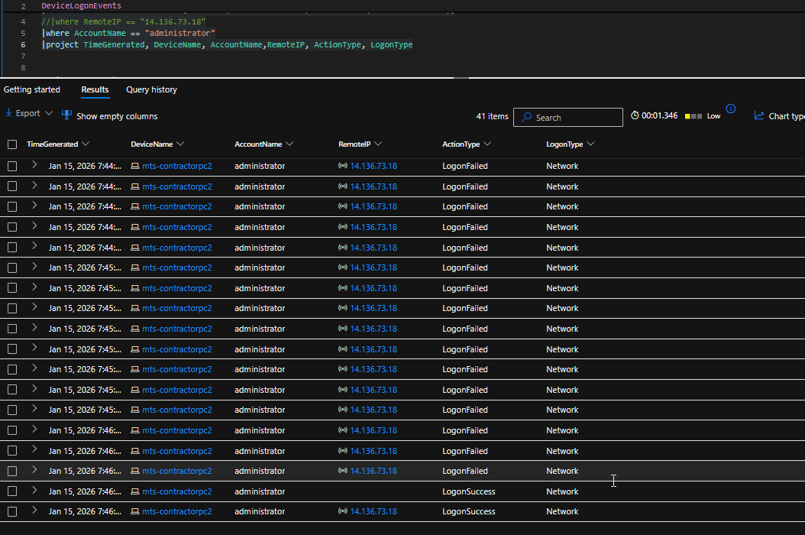

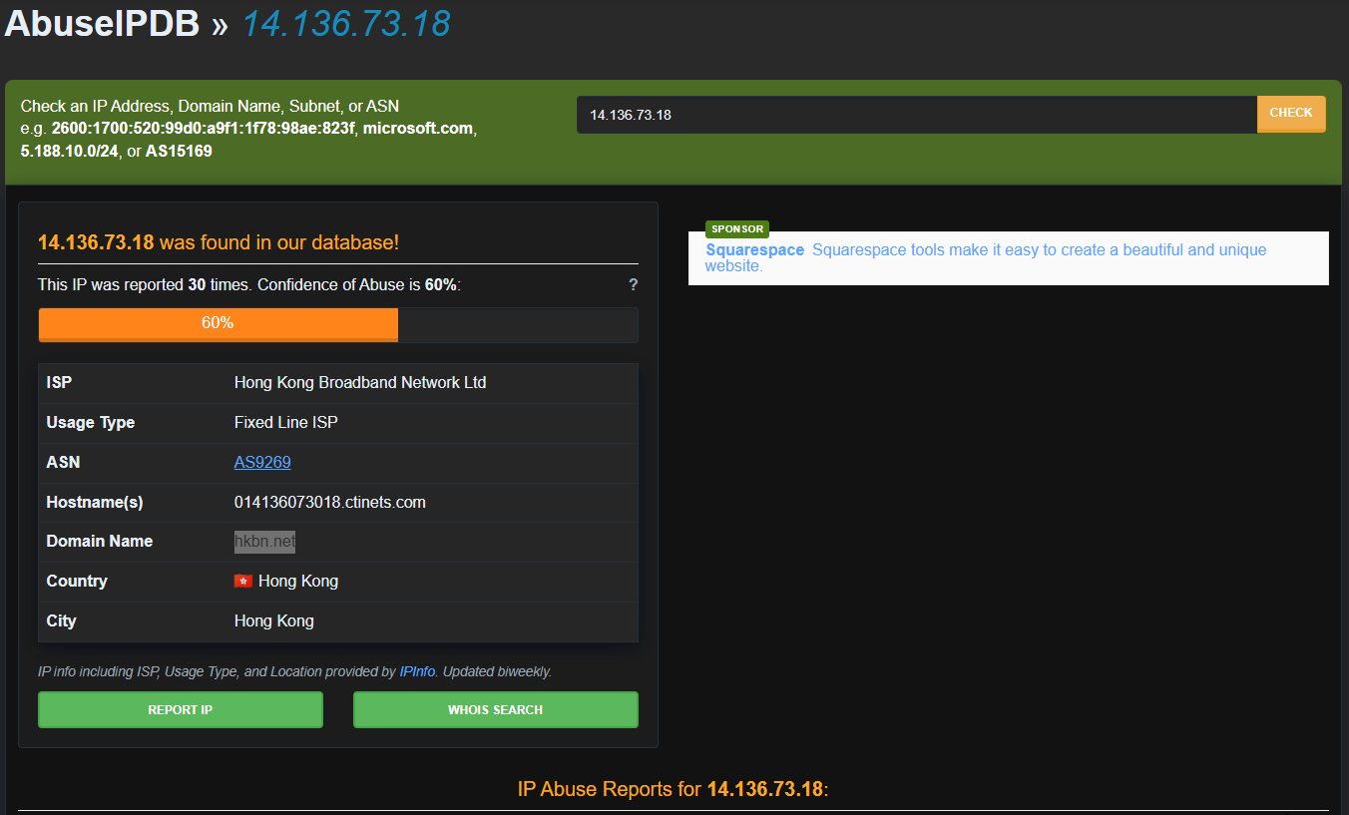
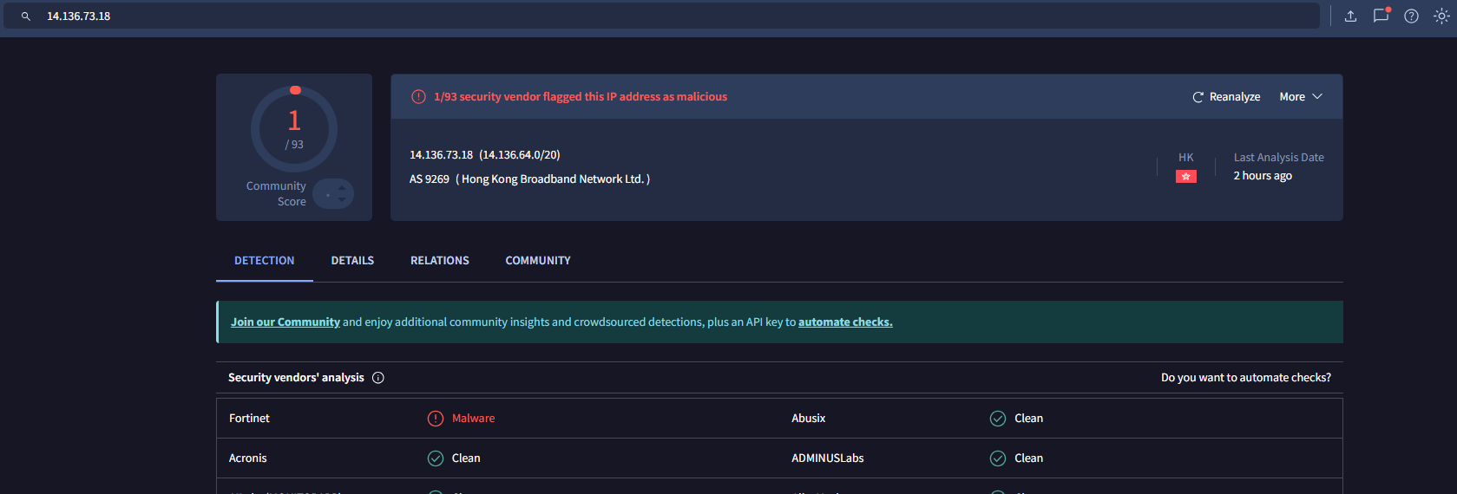

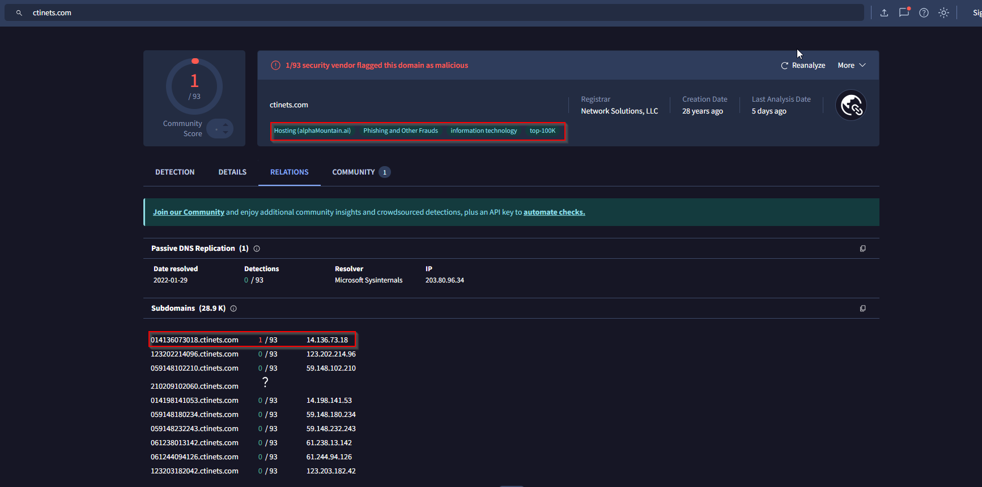

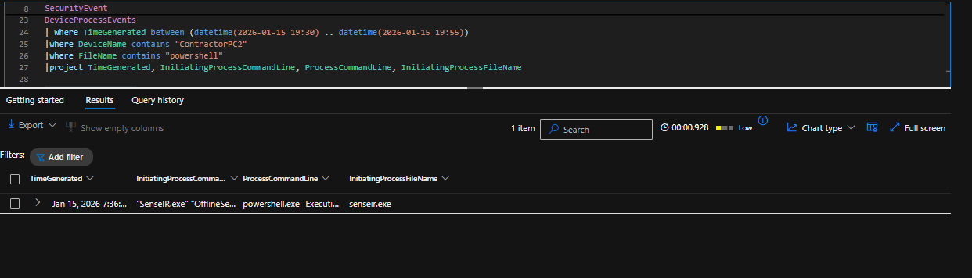

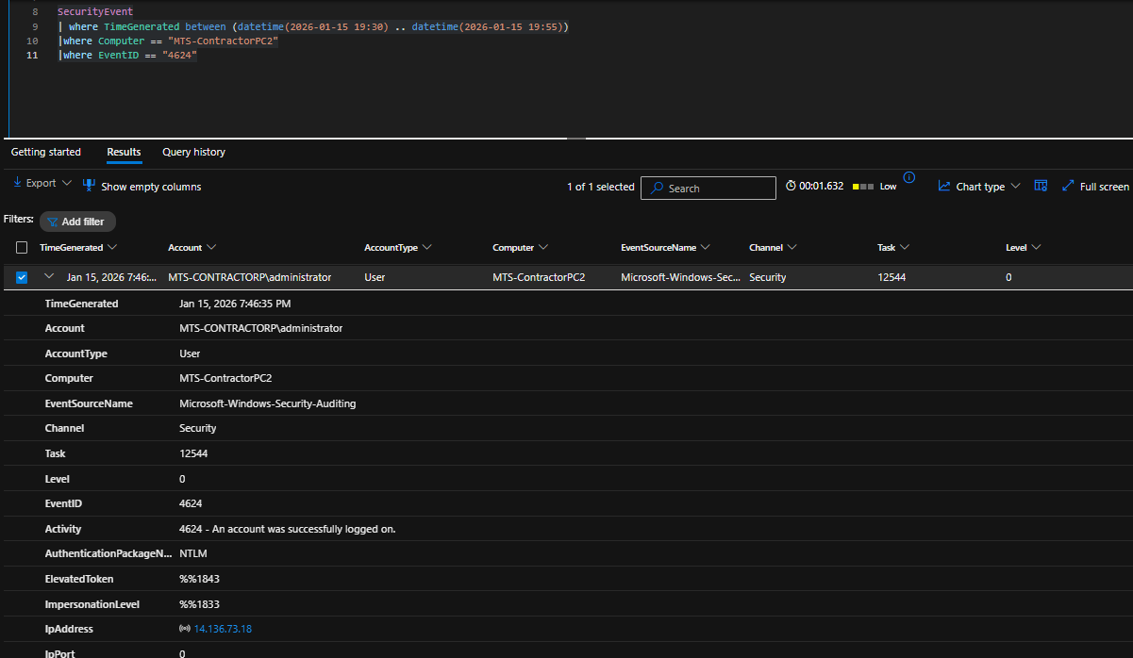

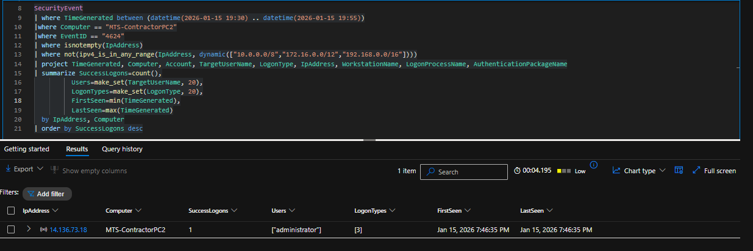

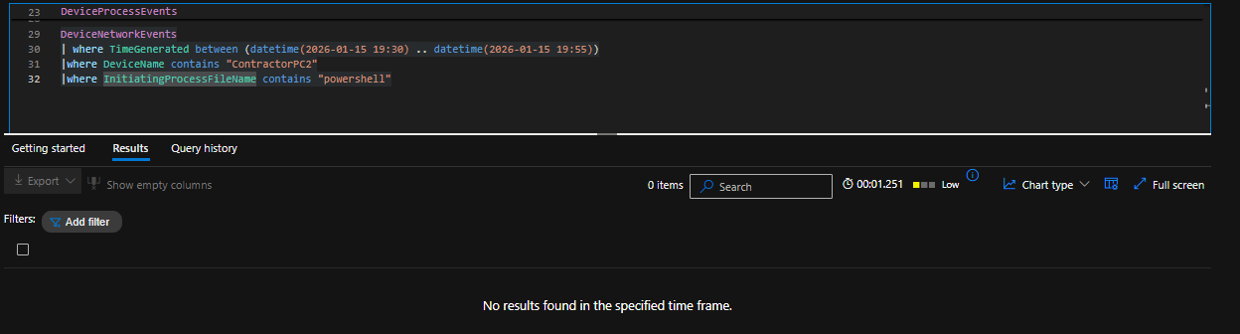

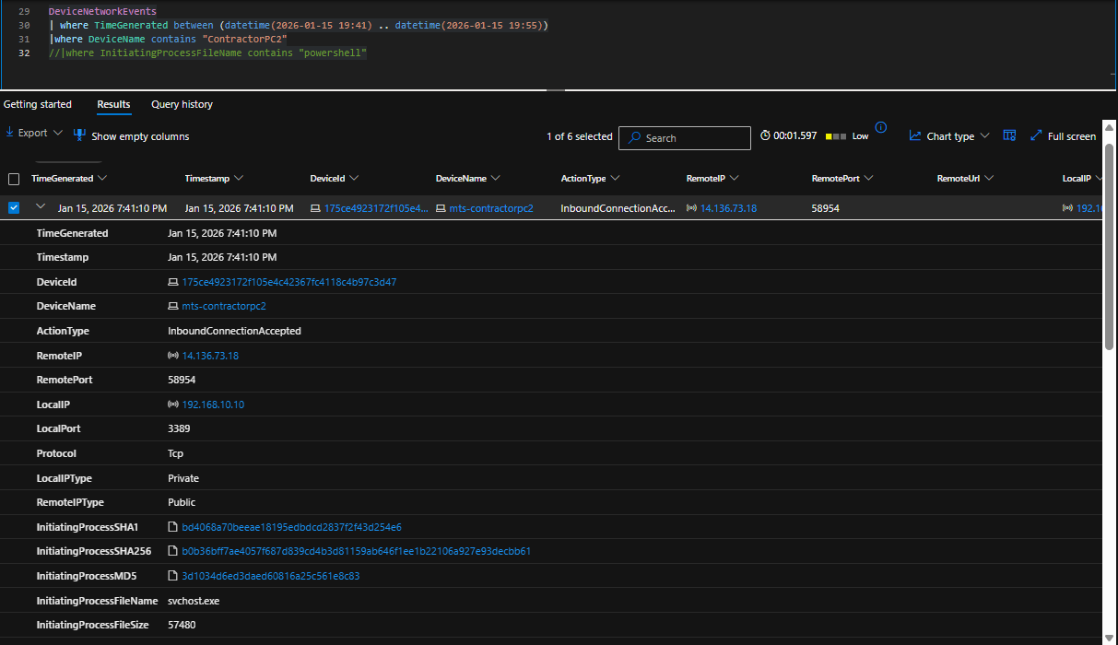

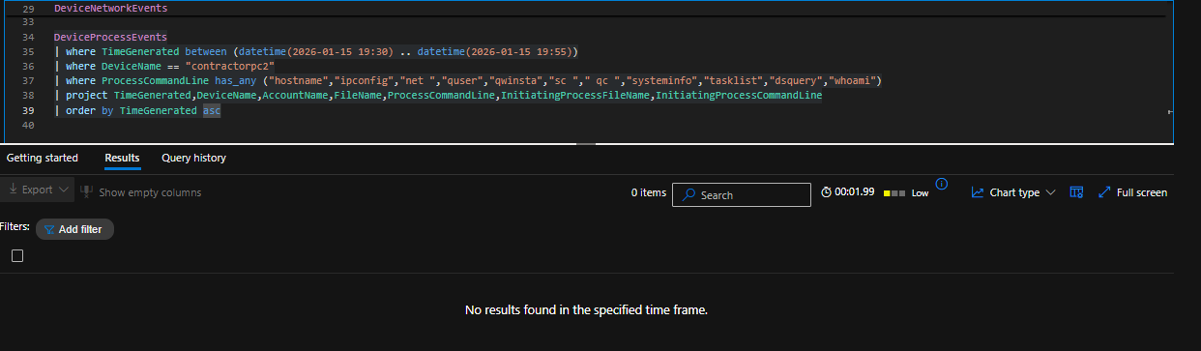
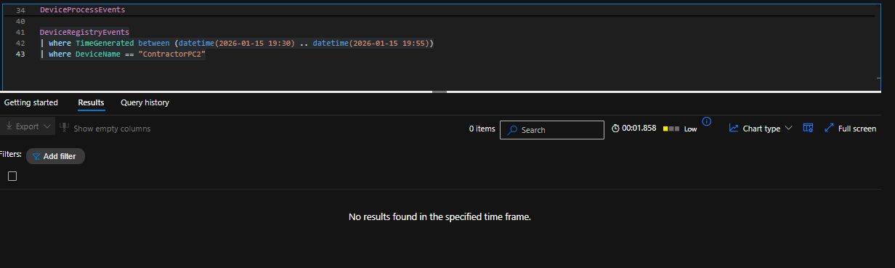

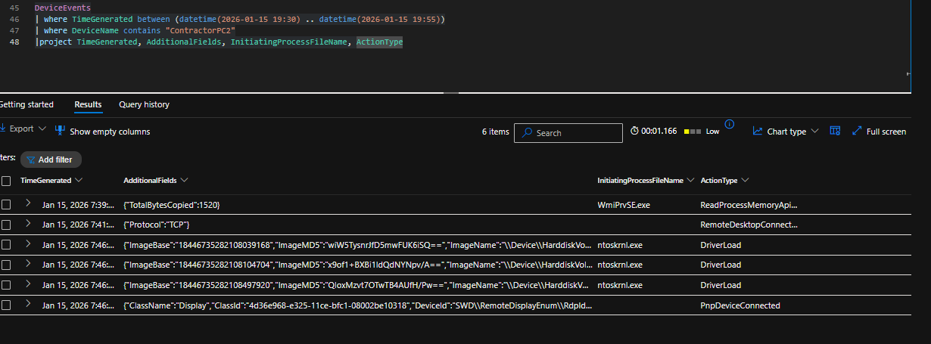

No Lateral Movement

